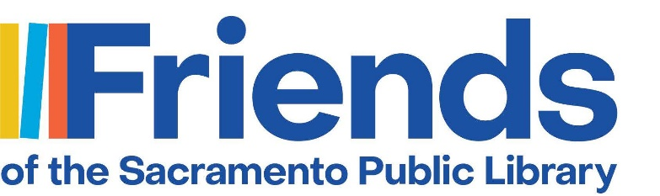
Calendar of Events
Black – Friend Affiliate Board Meeting/Volunteer Appreciation/Training/Sale
Bold-FSPL Board Meeting/All Friends Meeting/FSPL Committee Meeting/JPA

2026
August 2026
8/1 McClatchy Friends Board Meeting (9:30 a.m. – 11:30 a.m.)
8/? Walnut Grove Friends Board Meeting (5 p.m. – 6 p.m.)
8/12 Valley-Hi Friends Board Meeting (2 p.m. – 4 p.m.)
8/27 JPA Meeting 3 pm https://saclibrary.portal.civicclerk.com/
8/27 Galt Friends Board Meeting (9:20 a.m. – 10:20 a.m.)
September 2026
9/1-9-30 Valley-Hi Monthly Book Sale
9/1 McKinley Friends Board Meeting (6 p.m. – 7 p.m.)
9/8 FSPL Board Meeting 7 p.m. Zoom https://us02web.zoom.us/j/5985772670
9/11 North Natomas Board Meeting (3 p.m. – 5 p.m.)
9/15 Rio Linda Friends Board Meeting 3:30 p.m.
9/19 Elk Grove/Franklin Board Meeting, Elk Grove Library (10 a.m.-12 p.m.)
9/19 North Natomas Book Sale
9/24 JPA Meeting 3 pm https://saclibrary.portal.civicclerk.com/
9/22 Colonial Heights Friends Board meeting
9/24 Galt Friends Board Meeting (9:20 a.m. – 10:20 a.m.)
October 2026
10/? Walnut Grove Friends Board Meeting (5 p.m. – 6 p.m.)
10/22 Pocket Friends Board Meeting 6 p.m.
10/22 JPA Meeting 3 pm https://saclibrary.portal.civicclerk.com/
10/22 Galt Friends Board Meeting (9:20 a.m. – 10:20 a.m.)
Oct 23 Walnut Grove Book Sale (3pm -6pm)
Oct 24 Walnut Grove Book Sale (11am-2pm)
10/24 FSPL Membership Shredding Event (1 p.m. – 4 p.m.)
November 2026
11/3 McKinley Friends Board Meeting (6 p.m. – 7 p.m.)
11/7 McClatchy Friends Board Meeting (9:30 a.m. – 11:30 a.m.)
11/10 FSPL Board Meeting 7 p.m. Zoom https://us02web.zoom.us/j/5985772670
11/13 North Natomas Board Meeting (3 p.m. – 5 p.m.)
11/18 Valley-Hi Friends Board Meeting (2 p.m. – 4 p.m.)
11/21 Elk Grove/Franklin Board Meeting, Elk Grove Library (10 a.m.-12 p.m.)
11/24 Colonial Heights Friends Board meeting

December 2026
12/1-12/31 Valley-Hi Monthly Book Sale; Galt See’s Candy Sales
12/5 McClatchy Book Sale (11 a.m. – 3 p.m.)
12/5 North Natomas Book Sale
12/7 JPA Meeting 3 pm https://saclibrary.portal.civicclerk.com/
12/26 Galt Friends Board Meeting (9:20 a.m. – 10:20 a.m.)
January 2027
1/12 FSPL Board Meeting 7 p.m. Zoom https://us02web.zoom.us/j/5985772670
1/24 FSPL ANNUAL MEETING 1-3:30 North Natomas Library 12:30 refreshments
1/26 Colonial Heights Friends Board meeting
1/28 Pocket Friends Annual Meeting 6 p.m
1/29 North Natomas Annual Meeting 3 p.m.

